Project Progress Report

Name: Zhiwei Xin

Andrew Id: zxin

# Brief Description

The game can basically run. Most resources needed have been found, but most features are unimplemented.

# Screenshots

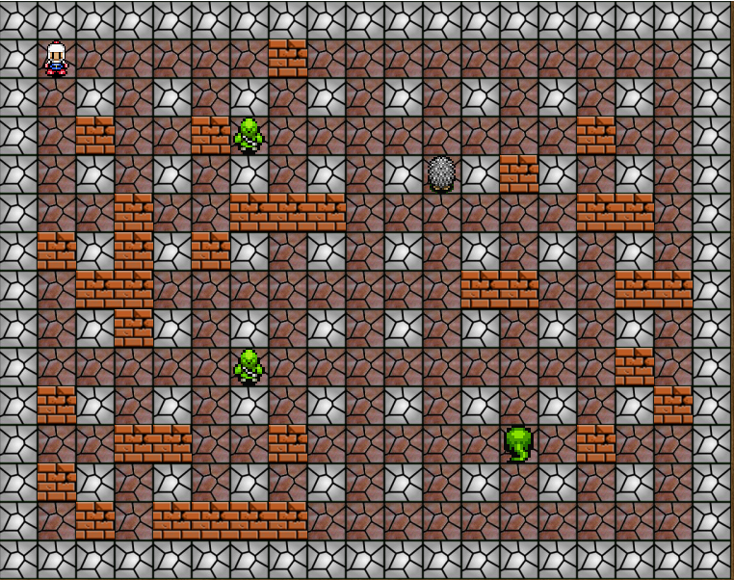

We can move the characters and the monsters can move itself, but collisions are not implemented

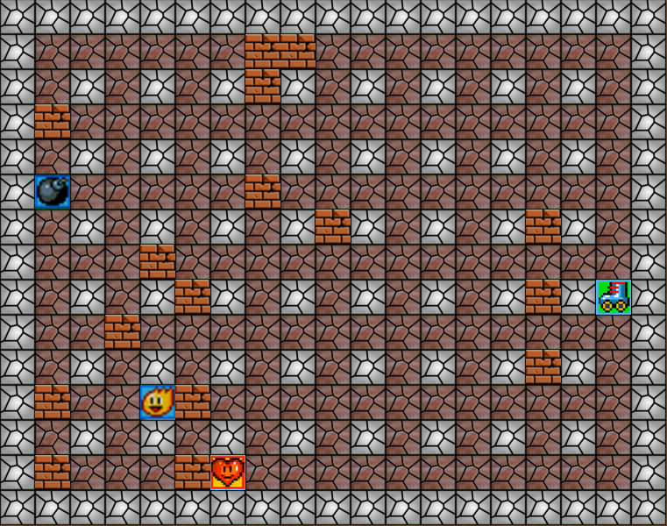

# Code snippets

I can provide the python files, but it seems code snippets are preferred.

If need python file, please contact me.

|  |
| --- |
| # This represents the bomb class. **import** configure **import** pygame   **class Bomb**(pygame.sprite.Sprite):  **def** __init__(self, player):  pygame.init()  pygame.sprite.Sprite.__init__(self)  self.c = configure.Configure()  imagePath = self.c.IMAGE_PATH + "/bomb.png"  self.image = pygame.image.load(imagePath).convert()  self.range = player.power # kill zone  self.triggered = False  self.countDown = 3 # how many seconds  self.owner = player  self.position = self.image.get_rect()  self.position = self.position.move((player.position.x,  player.position.y))  tsize = self.c.TILE_SIZE  self.rect = pygame.Rect(self.position[0], self.position[1], tsize, tsize)   **def countdown**(self):  self.countDown -= 1   **def explode**(self):  self.owner.curBombs += 1  # shall i add animation here |
| # The Character Class  **import** configure **import** copy **import** pygame   **class Character**(pygame.sprite.Sprite):  *"""docstring for Character"""* **def** __init__(self, idNum, position, thisType):  self.c = configure.Configure() # some constant   pygame.sprite.Sprite.__init__(self)  # super(Character,self).__init__() # Modified  pygame.init()  self.id = idNum   self.type = thisType # players/ enemies   size = (self.c.WIDTH, self.c.HEIGHT)  self.screen = pygame.display.set_mode(size)   self.getImage("down")   self.rect = self.image.get_rect()  self.position = self.image.get_rect()  self.move(position)   **def getImage**(self,direction):  self.direction = direction  **if** self.type == "players":  imagePath = self.c.IMAGE_PATH + "players/" +"p_"+str(self.id)+"_" + direction + ".png"  **else**:  imagePath = self.c.IMAGE_PATH + "enemies/" +"e_"+str(self.id)+"_" + direction + ".png"   self.image = pygame.image.load(imagePath).convert()    # solve the face to   **def face**(self,key):  self.getImage(key)   **def moveSquare**(self,key):  **if** key == pygame.K_RIGHT:  self.face("right")  **return** (1*self.c.TILE_SIZE, 0)  **elif** key == pygame.K_LEFT:  self.face("left")  **return** (-1*self.c.TILE_SIZE, 0)  **elif** key == pygame.K_UP:  self.face("up")  **return** (0, -1*self.c.TILE_SIZE)  **elif** key == pygame.K_DOWN:  self.face("down")  **return** (0, 1 * self.c.TILE_SIZE)    **def move**(self,point):  self.old = copy.copy(self.rect)   dx,dy = point[0],point[1]  self.rect.x,self.rect.y = self.rect.x + dx,self.rect.y+dy  self.position = self.position.move(point)     **def updateRect**(self):  tSize = self.c.TILE_SIZE    **def update**(self):  self.updateRect()  # --------- test code ------------- #  **def innerRun**(self):  pygame.init()  size = (700, 500)  screen = pygame.display.set_mode(size)   user = Character(1,(40,40),"players")  self.userGroup = pygame.sprite.Group(user)  # self.userGroup.add(self.user)   # self.screen.blit(self.image.convert(),[0,0])  pygame.display.set_caption("My Test")    # Loop until the user clicks the close button.  done = False    # Used to manage how fast the screen updates  clock = pygame.time.Clock()    # -------- Main Program Loop -----------  **while not** done:  # --- Main event loop  **for** event **in** pygame.event.get():  **if** event.type == pygame.QUIT:  done = True  **elif** event.type == pygame.KEYDOWN:  **if** event.key **in** [pygame.K_LEFT,pygame.K_RIGHT,pygame.K_UP,pygame.K_DOWN]:  point = user.moveSquare(event.key)  user.move(point)   screen.fill((255,255,255))  self.userGroup.draw(screen)  # --- Game logic should go here    # --- Drawing code should go here    # First, clear the screen to white. Don't put other drawing commands  # above this, or they will be erased with this command.   # --- Go ahead and update the screen with what we've drawn.  pygame.display.flip()    # --- Limit to 60 frames per second  clock.tick(30)    # Close the window and quit.  # If you forget this line, the program will 'hang'  # on exit if running from IDLE.  pygame.quit() |
| # enemy **import** pygame, character, random   **class Enemy**(character.Character):  *"""docstring for Enemy"""* **def** __init__(self, idNum, position, thisType):  # super().__init__(idNum,position,thisType)  character.Character.__init__(self, idNum, position, thisType)   **def movement**(self):  patterns = [pygame.K_UP, pygame.K_DOWN, pygame.K_LEFT, pygame.K_RIGHT]   # this move pattern can be improved  **return** self.moveSquare(random.choice(patterns)) |
| # The Game Menu   **import** pygame, configure, instructions, game, pickle, maps, costumizedLevel **import** highscore  # constant PTS_WIDTH = 1024 # pre screen width PTS_HEIGHT = 768 # pre Screen height   **class TitleScreen**(object):  **def** __init__(self):  self.c = configure.Configure()  done = False  pygame.init()  clock = pygame.time.Clock()  self.modifyMap = False  wantToEnd = False  **while not** done:  self.screen = pygame.display.set_mode([PTS_WIDTH, PTS_HEIGHT])  pygame.display.set_caption("Bomberman")   # import background image  bgImagePath = self.c.IMAGE_PATH + "titleScreen.png"  bgImage = pygame.image.load(bgImagePath).convert()  bgImage = pygame.transform.scale(bgImage, (PTS_WIDTH, PTS_HEIGHT))  self.screen.blit(bgImage, [0, 0])   pygame.mixer.music.load(self.c.AUDIO_PATH + "title.mid")  pygame.mixer.music.play()   notValidOp = False  # under valid control mode  **while not** notValidOp:  # get mouse position  pos = pygame.mouse.get_pos()  # testCode  **for** event **in** pygame.event.get():  # deal with the exit  **if** event.type == pygame.QUIT:  notValidOp = **not** notValidOp  done = **not** done  wantToEnd = True   # load the game  **elif** event.type == pygame.KEYDOWN:  **if** event.key == pygame.K_l:  **with** open("saved.pickle", "rb") **as** f:  self.total = pickle.load(f)  f.close()  self.playGame(self.c.SINGLE, self.total)   **elif** event.type == pygame.MOUSEBUTTONDOWN:  # map editor  **if** self.inBoundary(pos[0], pos[1], 25, 450, 250, 500):  # customize the map  costumizedLevel.CustomizedLevel()  # the following code are necessary for python3  notValidOp = **not** notValidOp  # it should work like above, when finished one op  # it should jump the loop so the video and music  # can be reinitialized again.  # single  **elif** self.inBoundary(pos[0], pos[1], 25, 500, 250, 550):  pygame.mixer.music.fadeout(1000)  self.playGame(self.c.SINGLE, None)  # following code are necessary for python 3  notValidOp = **not** notValidOp   # multi  **elif** self.inBoundary(pos[0], pos[1], 25, 550, 250, 600):  pygame.mixer.music.fadeout(1000)  self.playGame(self.c.MULTI, None)  # the following code are necessary for python3  notValidOp = **not** notValidOp   # instructions  **elif** self.inBoundary(pos[0], pos[1], 25, 600, 250, 650):  self.instructions()   notValidOp = **not** notValidOp  # it should work like above, when finished one op  # it should jump the loop so the video and music  # can be reinitialzed again.   # high Score  **elif** self.inBoundary(pos[0], pos[1], 25, 650, 250, 700):  self.highScores()   notValidOp = **not** notValidOp  # it should work like above, when finished one op  # it should jump the loop so the video and music  # can be reinitialzed again.   # exit  **elif** self.inBoundary(pos[0], pos[1], 40, 700, 250, 750):  done = **not** done  notValidOp = **not** notValidOp  # wantToEnd = True   # Go ahead and update the screen with what we've drawn.   pygame.display.flip()   # Limit to 60 frames per second  clock.tick(self.c.FPS)   pygame.quit()   **def inBoundary**(self, x0, y0, x1, y1, x2, y2):  **if** (x1 <= x0 <= x2) **and** (y1 <= y0 <= y2):  **return** True  **return** False   **def instructions**(self):  instructions.Instructions()   **def playGame**(self, mode, saved):  game.Game(mode, saved)   **def highScores**(self):  hs = highscore.HighScores()  hs.displayScores() |